Table of Contents

ICT YouTube Tutorial 2

ICT Execution Video 2

NQZ2025 Overall Analysis 3

NQZ2025 Daily Analysis 4

NQZ2025 My Mistake ❤️ 5

NQZ2025 Daily Premium Wick 6

📌 *What does Intraday Chart mean?* 7

NQZ2025 1m Analysis 8

📌 *Market Structure Shift (MSS) in ICT concepts* 11

NQZ2025 My Mistake ❤️ 18

DXY Old Daily Analysis 21

DXY Daily Analysis 23

DXY 5m Analysis 27

DXY My Mistake ❤️ 32

GBPUSD Daily Analysis 34

GBPUSD 5m Analysis 38

# ICT YouTube Tutorial

Trading All Time Highs and Disregarding TGIF ( <https://www.youtube.com/watch?v=b4DOrfGau8w> )

# ICT Execution Video

Trading Friday Sellside Under 1st Presented FVG ( <https://www.youtube.com/watch?v=POUT0pVs4U0> )

#### TGIF in ICT Trading – Summary

* **TGIF = Thank God It’s Friday**  
  In ICT it refers to a specific setup that happens on Fridays.
* If the weekly trend is **Bullish**:  
  On Friday you expect a retracement of **20–30%** (sometimes up to 40%) of the weekly range *downwards*.
* If the weekly trend is **Bearish**:  
  On Friday you expect a retracement of **20–30%** (sometimes up to 40%) of the weekly range *upwards*.
* **Exception:**  
  If the market is at **All-Time Highs**, you should ignore TGIF, because the market can keep pushing higher without a meaningful retracement.

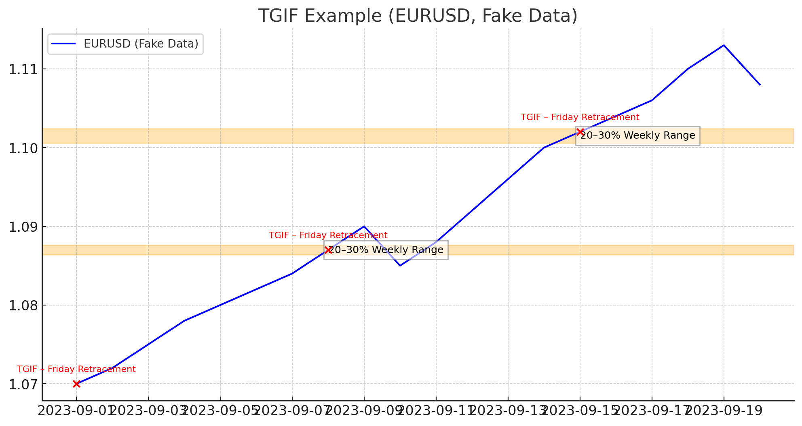

# NQZ2025 Overall Analysis

<https://www.tradingview.com/x/yGaJ2EM6/>

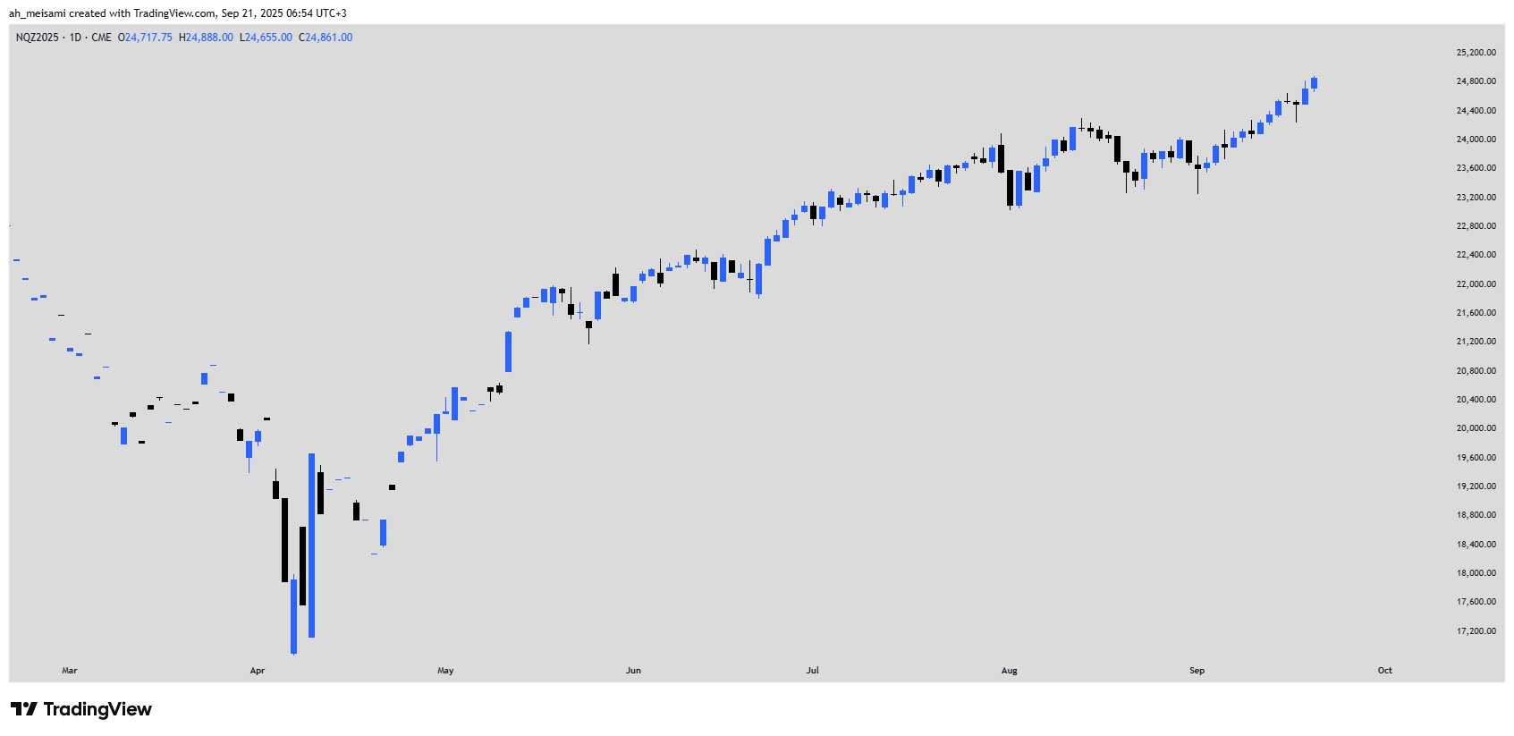

## NQZ2025 Daily Analysis

<https://www.tradingview.com/x/rd4bWvQ6/>

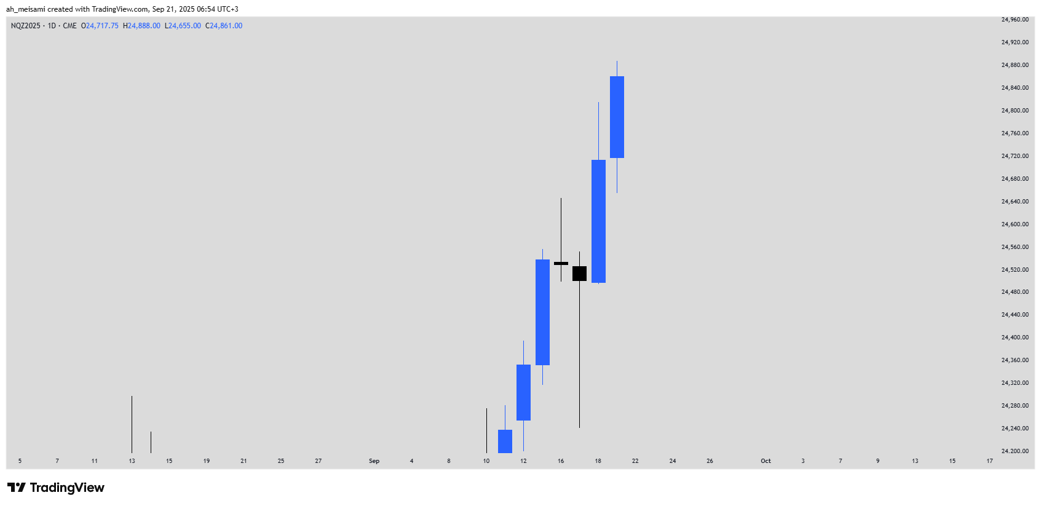

### NQZ2025 My Mistake ❤️

<https://www.tradingview.com/x/0LZkbQhh/>

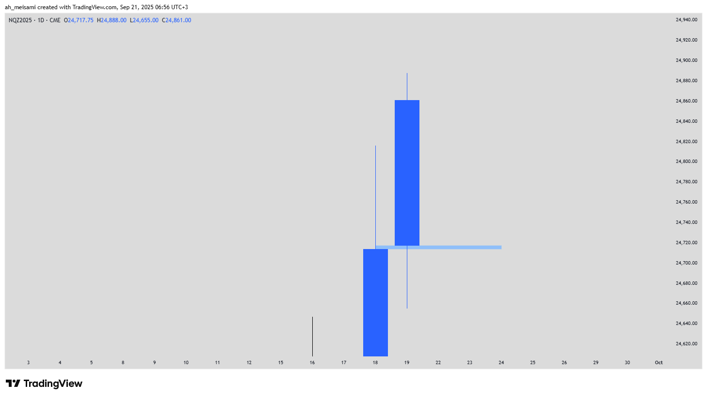

## NQZ2025 Daily Premium Wick

<https://www.tradingview.com/x/5CgKRrqS/>

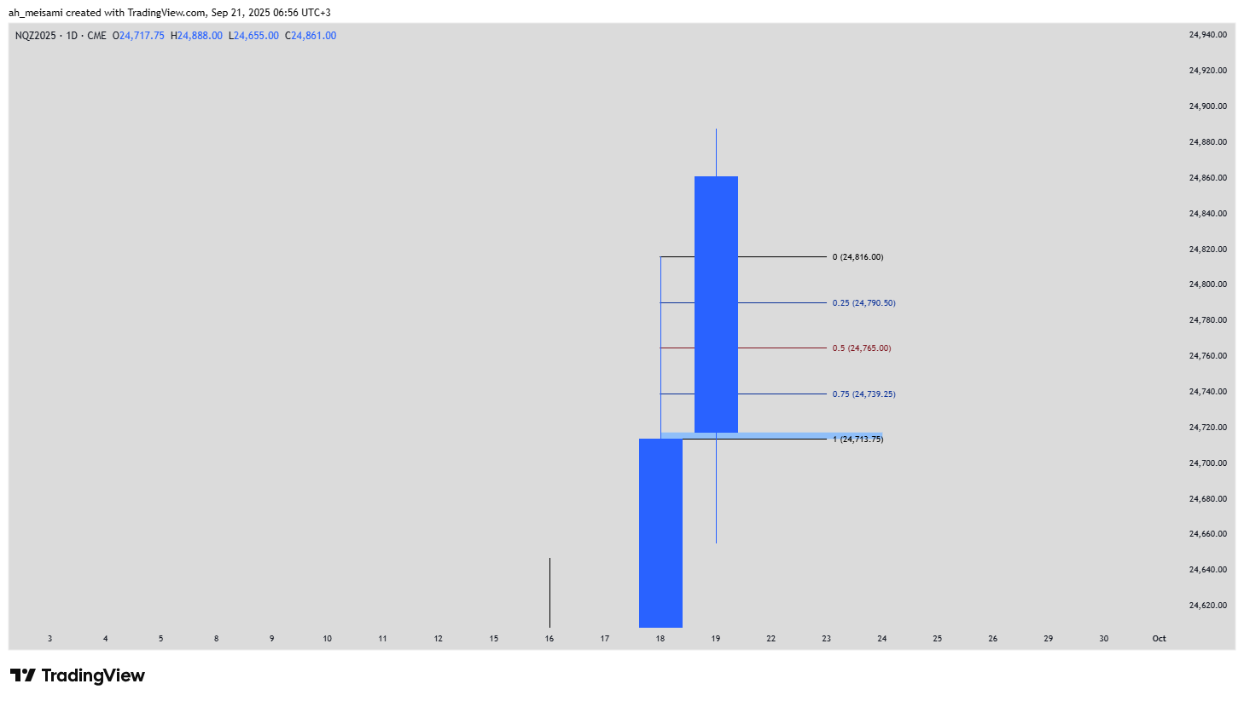

## 📌 What does Intraday Chart mean?

* **Intraday = within the same trading day.**
* It refers to charts that show price movements inside one trading day.
* Common intraday timeframes:
  + 1 minute (M1)
  + 5 minutes (M5)
  + 15 minutes (M15)
  + 1 hour (H1)

Unlike **Daily Chart** (where each candle = 1 full day) or **Weekly Chart** (1 candle = 1 week), on an **Intraday Chart** each candle represents only a small part of the day.

🎯 Why ICT uses Intraday Charts?

* To study **precise price movements inside the same day**
* To identify **liquidity pools** (intraday highs/lows)
* To spot **Fair Value Gaps (FVGs)** and **Market Structure Shifts (MSS)** with high detail

👉 So when ICT says “Intraday Chart”, he usually means a **1m, 5m, or 15m chart** to break down the daily price action in more detail.

## NQZ2025 1m Analysis

<https://www.tradingview.com/x/yH0HbAoo/>

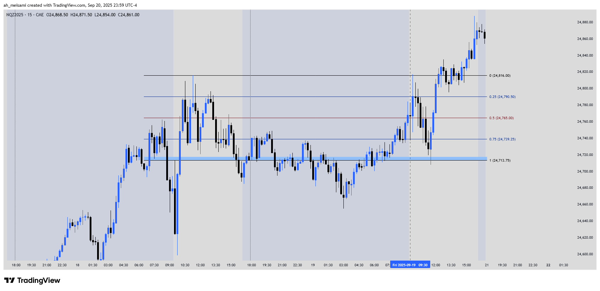

<https://www.tradingview.com/x/dNGp0hGc/>

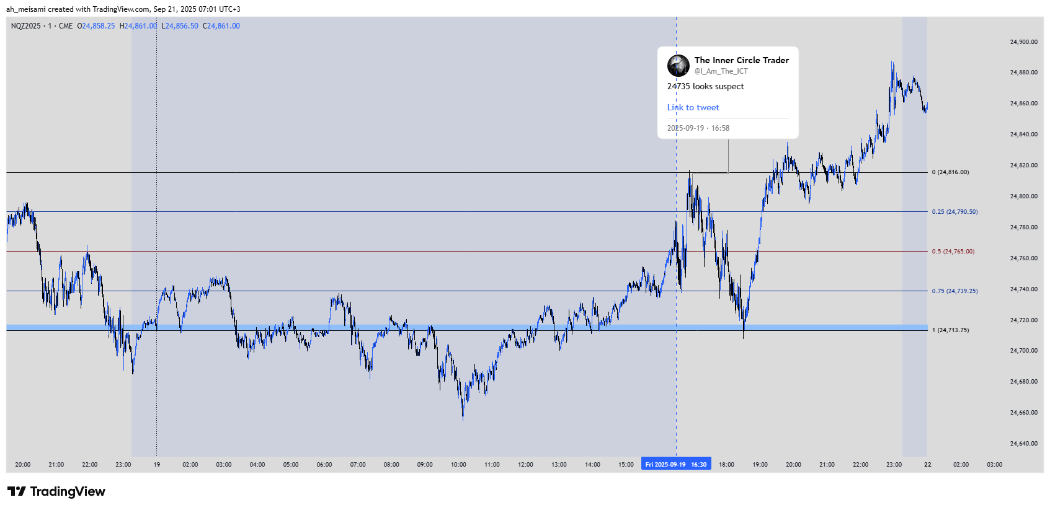

<https://www.tradingview.com/x/1RAsmoOt/>

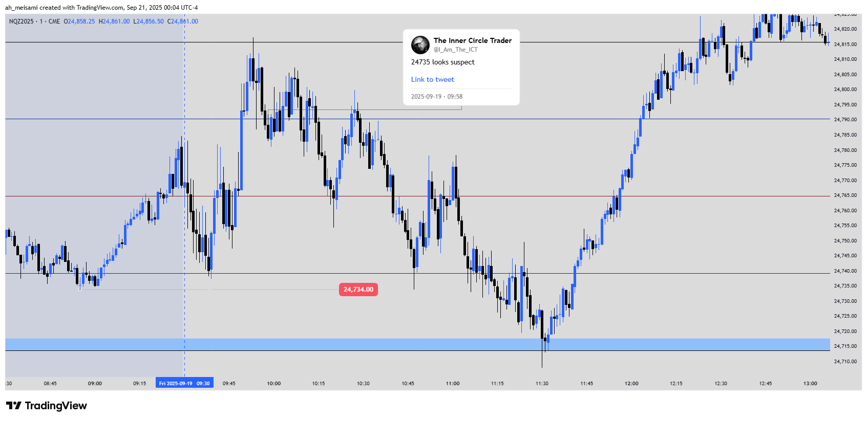

## 📌 Market Structure Shift (MSS) in ICT concepts

* **Market Structure** = the sequence of highs and lows that defines the trend.
* **MSS = a change of market structure** → it happens when price breaks a key swing point **in the opposite direction** of the current trend.

🔹 Example:

* If the market is making **Higher Highs + Higher Lows** (bullish trend),  
  → a **break below the last swing low with a candle body close** = bearish MSS.
* If the market is making **Lower Lows + Lower Highs** (bearish trend),  
  → a **break above the last swing high with a candle body close** = bullish MSS.

🎯 ICT’s emphasis

* **A wick alone is not enough** → the candle must **close with the body** beyond the level.
* Many fake breaks are only **liquidity grabs** (stop hunts), not true MSS.
* MSS is often combined with **Fair Value Gap (FVG):** after the shift, price usually retraces into the FVG and then continues.

📌 In short:  
For ICT, **MSS is a valid signal of potential trend reversal**, but it must be confirmed with candle body close and context (liquidity + FVG).

<https://www.tradingview.com/x/zIaaDT0w/>

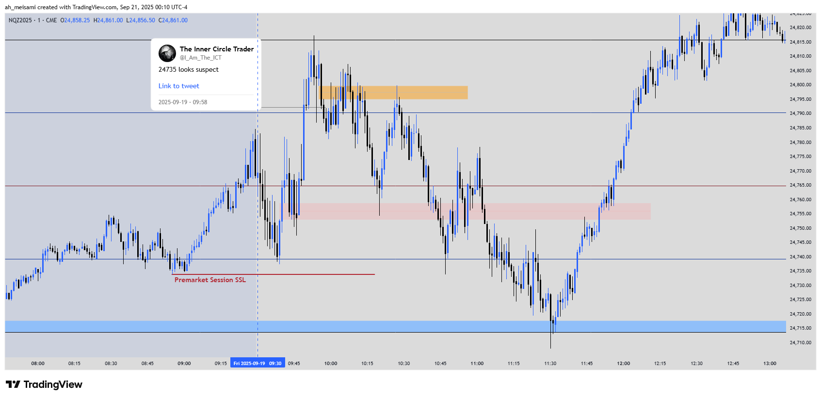

<https://www.tradingview.com/x/zrY41Xkg/>

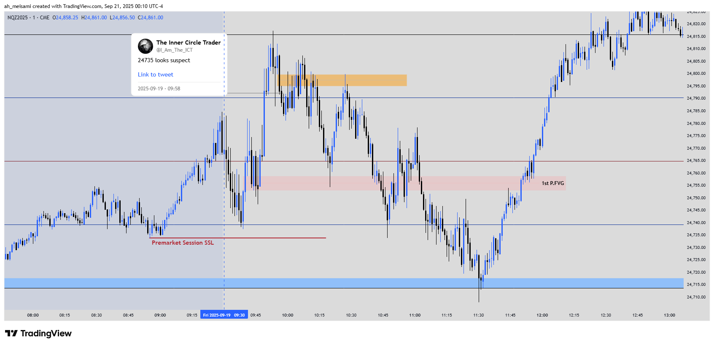

<https://www.tradingview.com/x/yxEAczTk/>

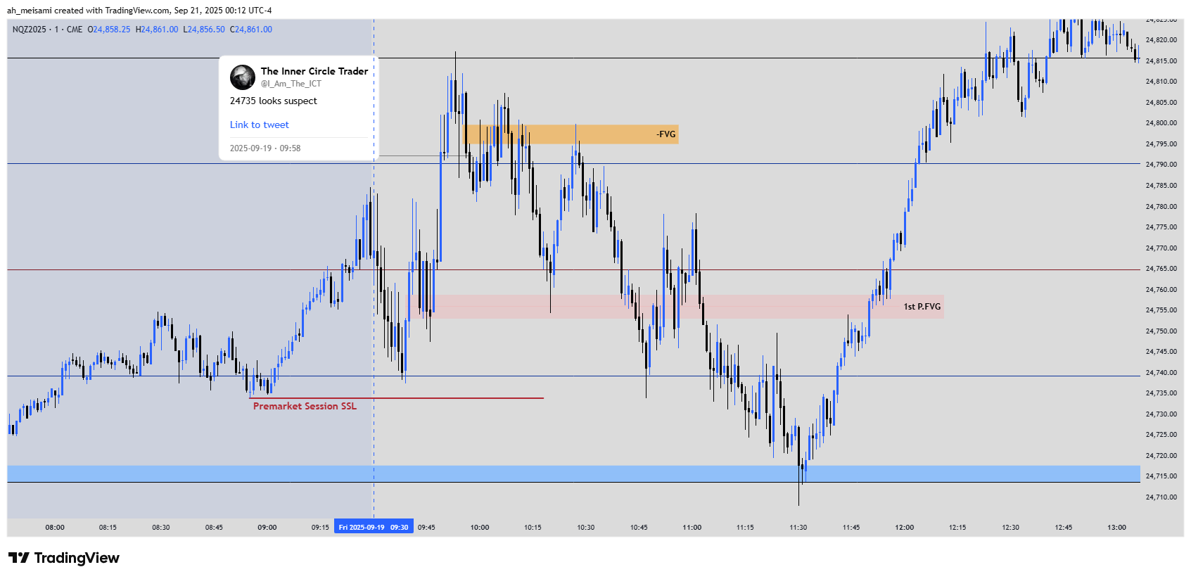

<https://www.tradingview.com/x/BvWMghqV/>

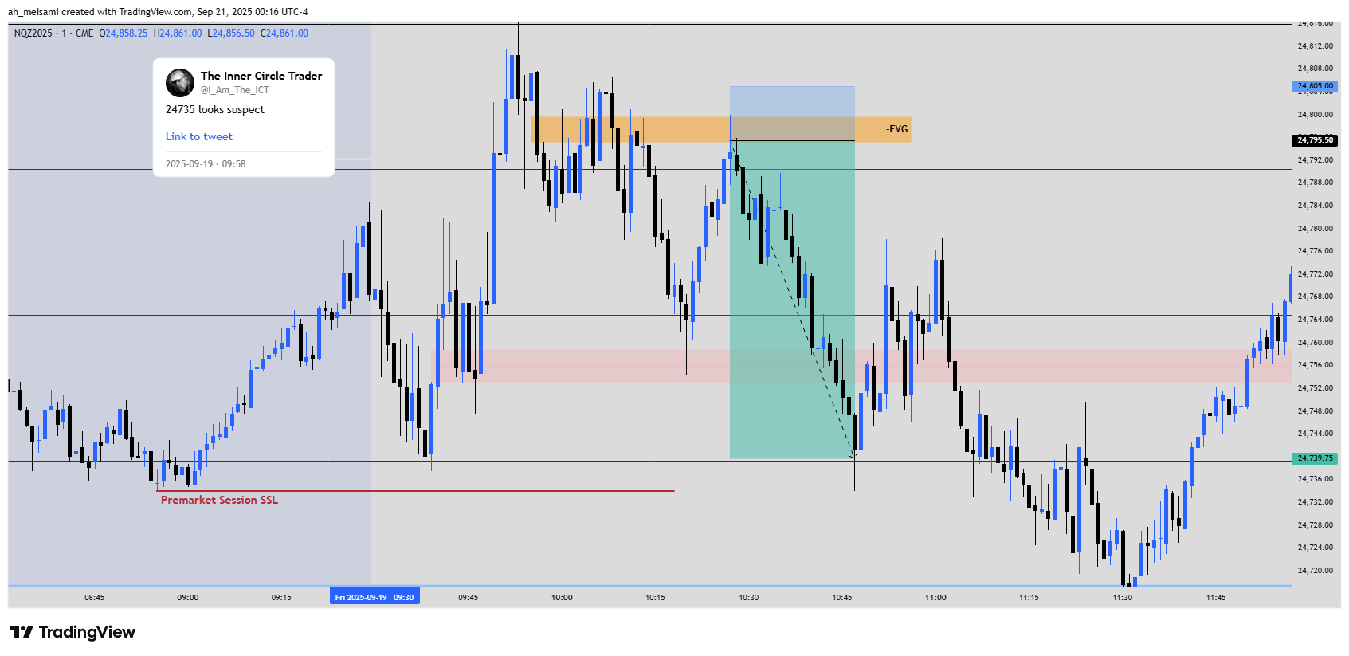

<https://www.tradingview.com/x/jtwE0w8T/>

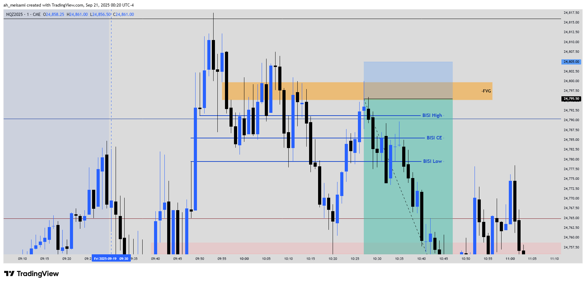

<https://www.tradingview.com/x/UyR78KVF/>

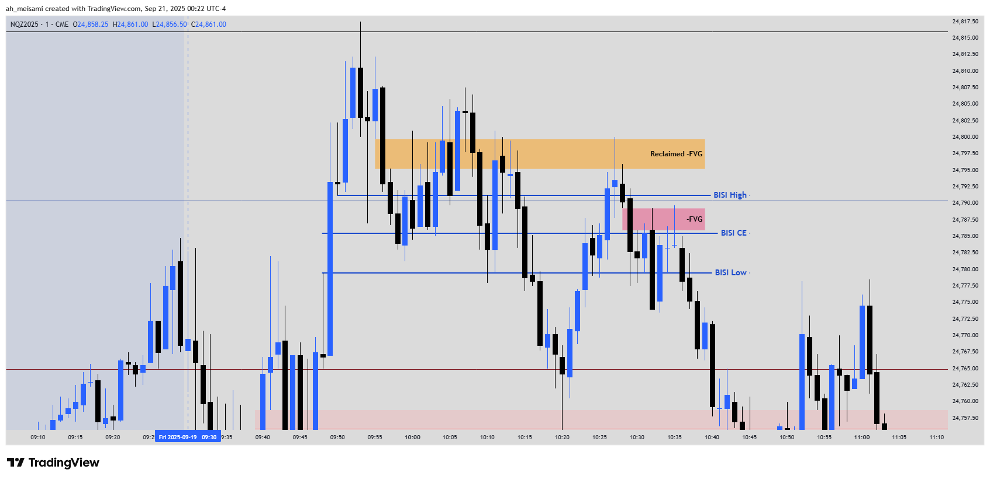

### NQZ2025 My Mistake ❤️

<https://www.tradingview.com/x/K6KYt4PD/>

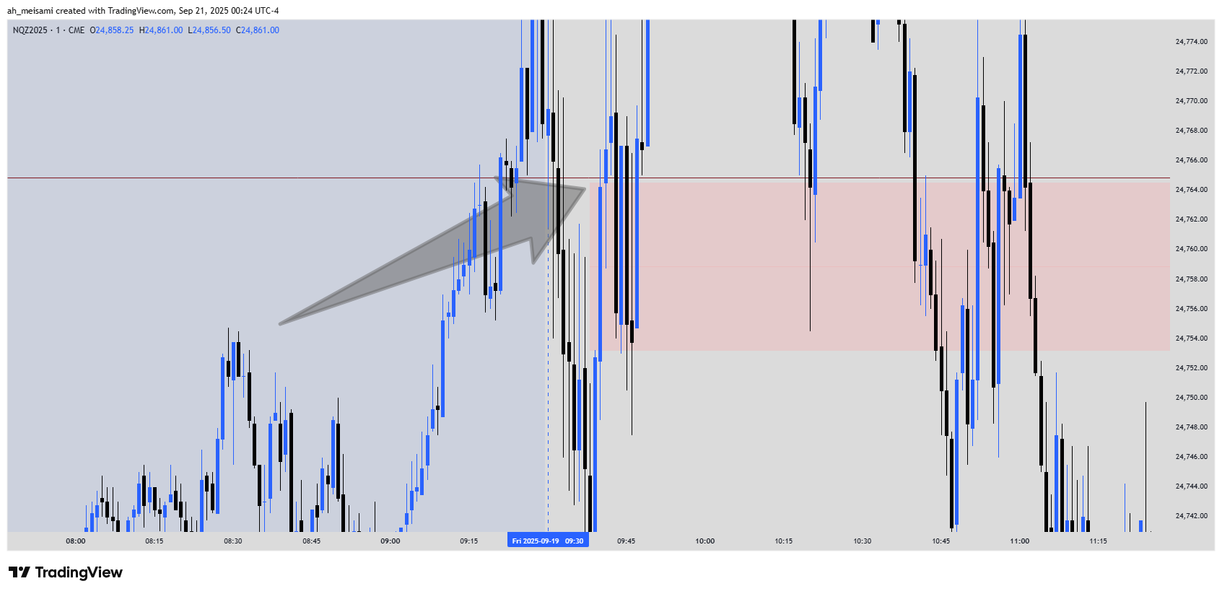

<https://www.tradingview.com/x/dmTJSkzu/>

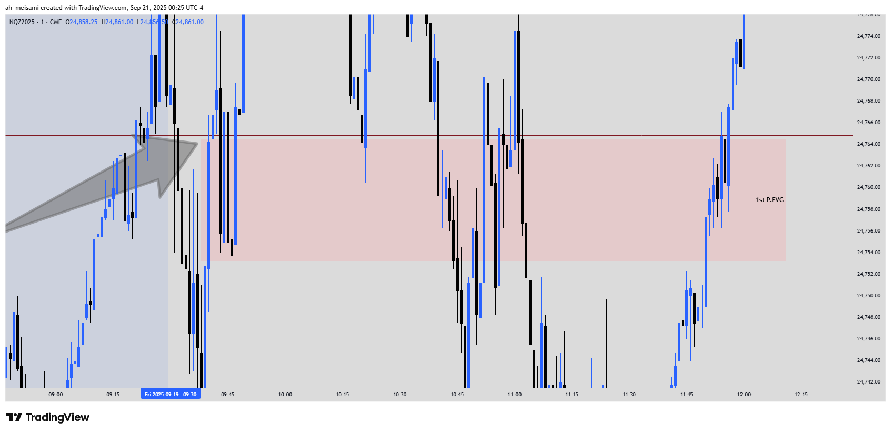

<https://www.tradingview.com/x/UraWxJ01/>

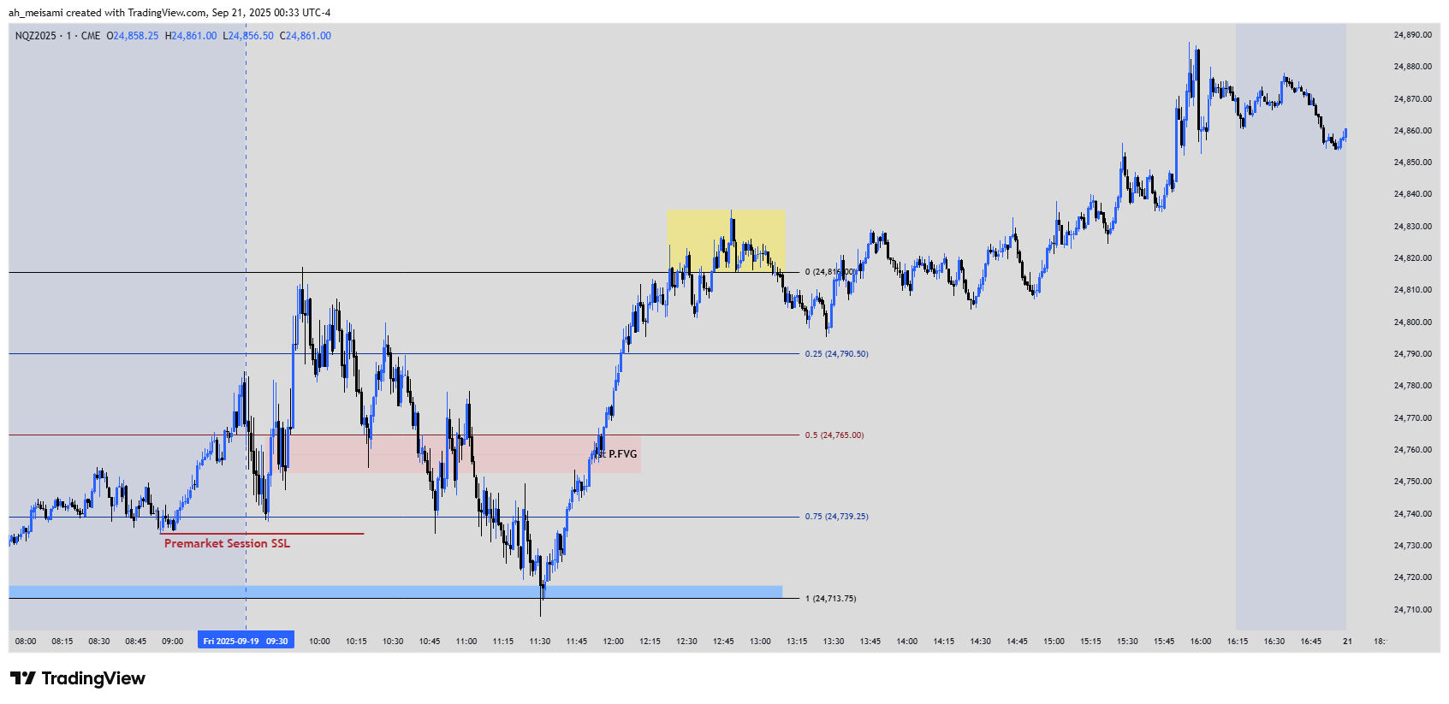

# DXY Old Daily Analysis

<https://www.tradingview.com/x/IQvLewAy/>

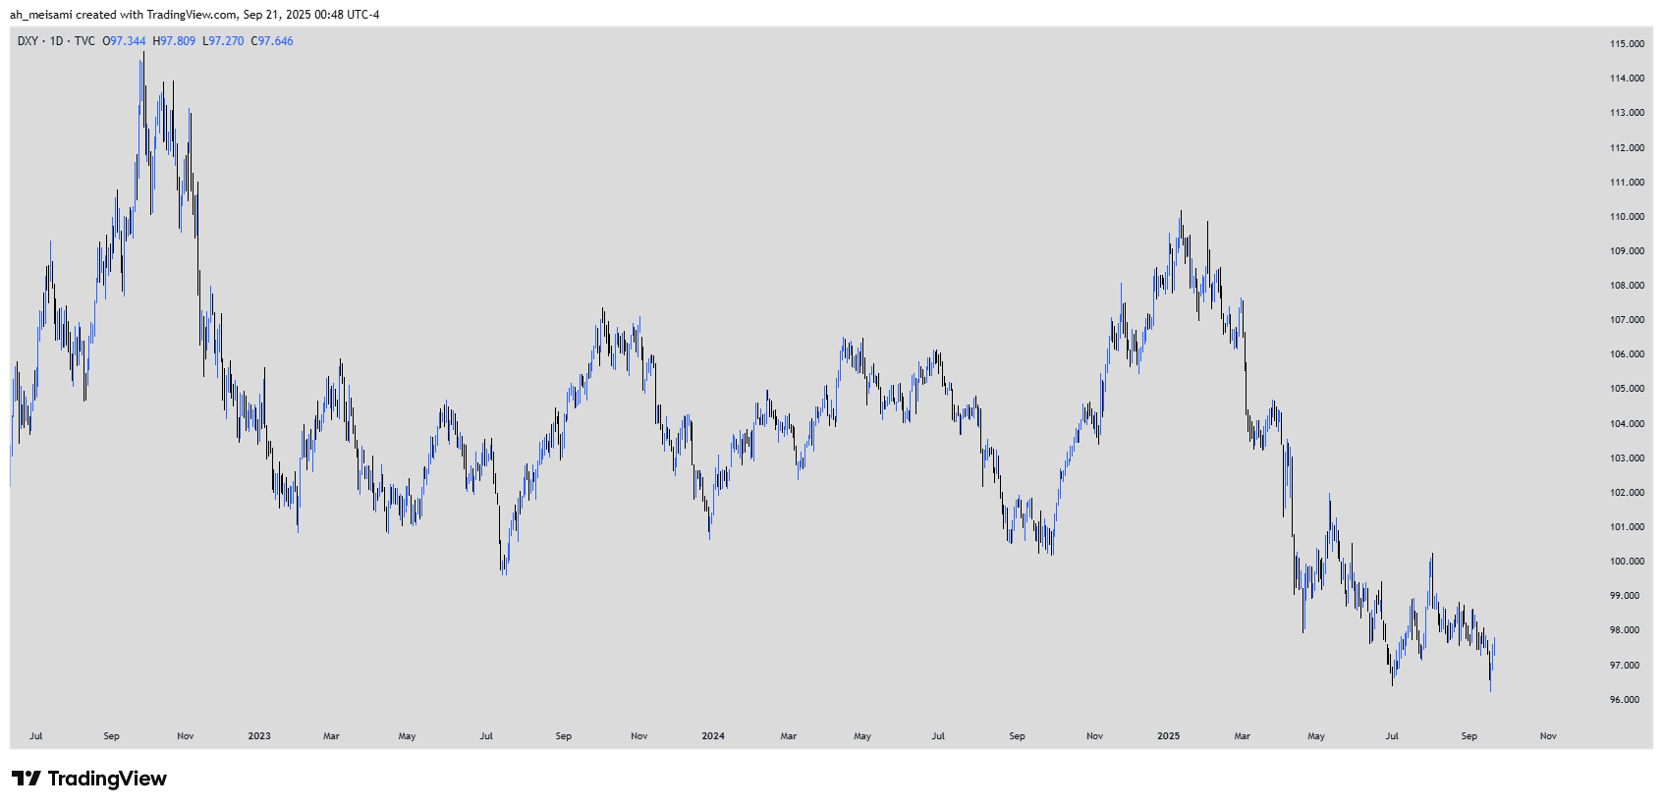

<https://www.tradingview.com/x/tGuUa74f/>

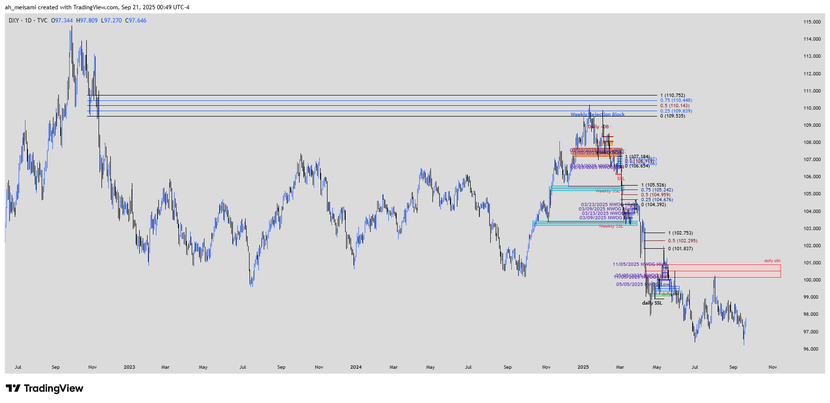

# DXY Daily Analysis

<https://www.tradingview.com/x/KppcGWtc/>

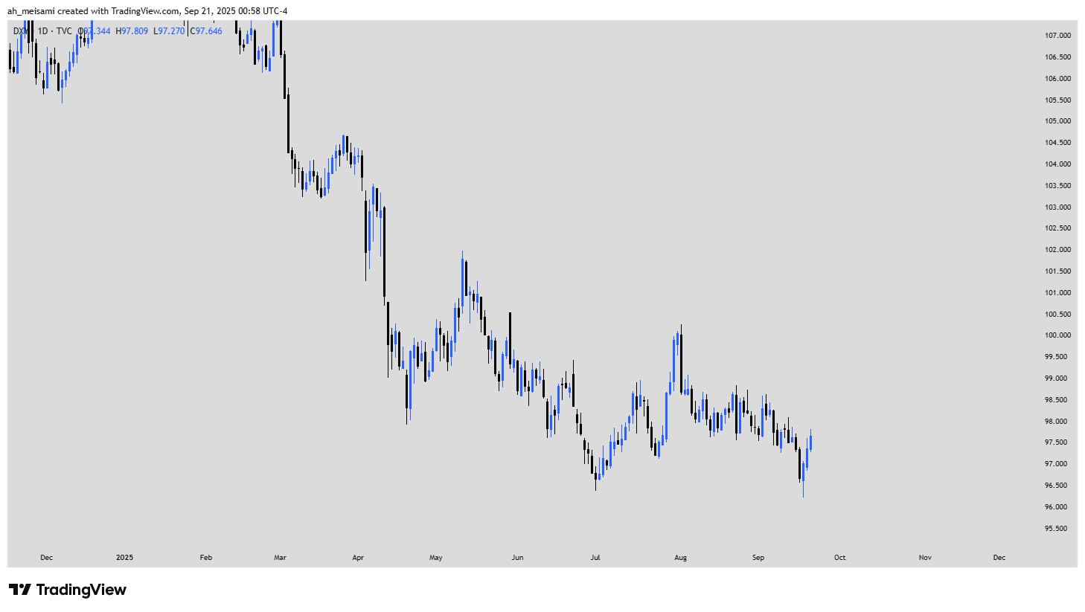

<https://www.tradingview.com/x/1N2M2I1f/>

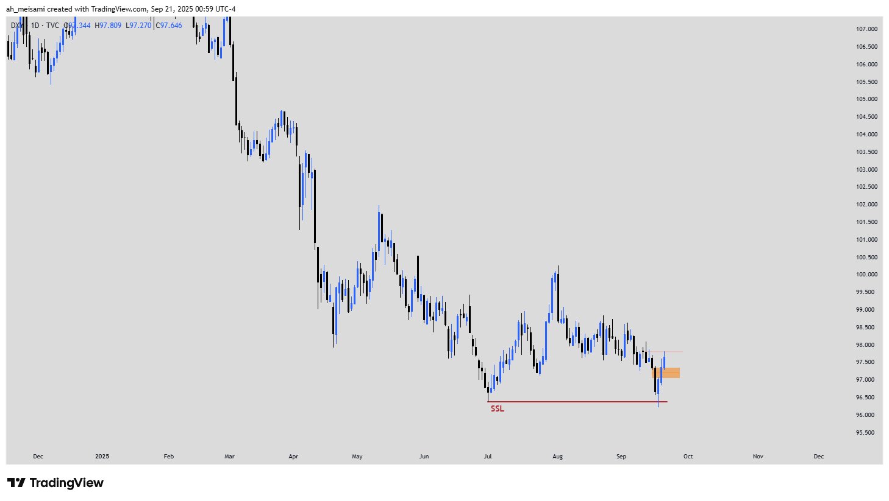

<https://www.tradingview.com/x/kzarDdI9/>

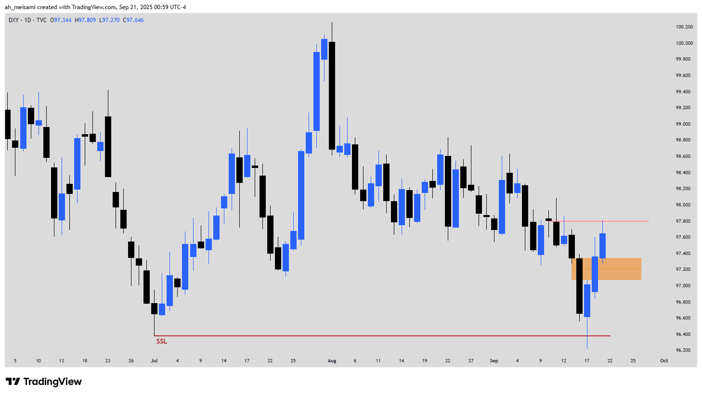

<https://www.tradingview.com/x/GExQvrsS/>

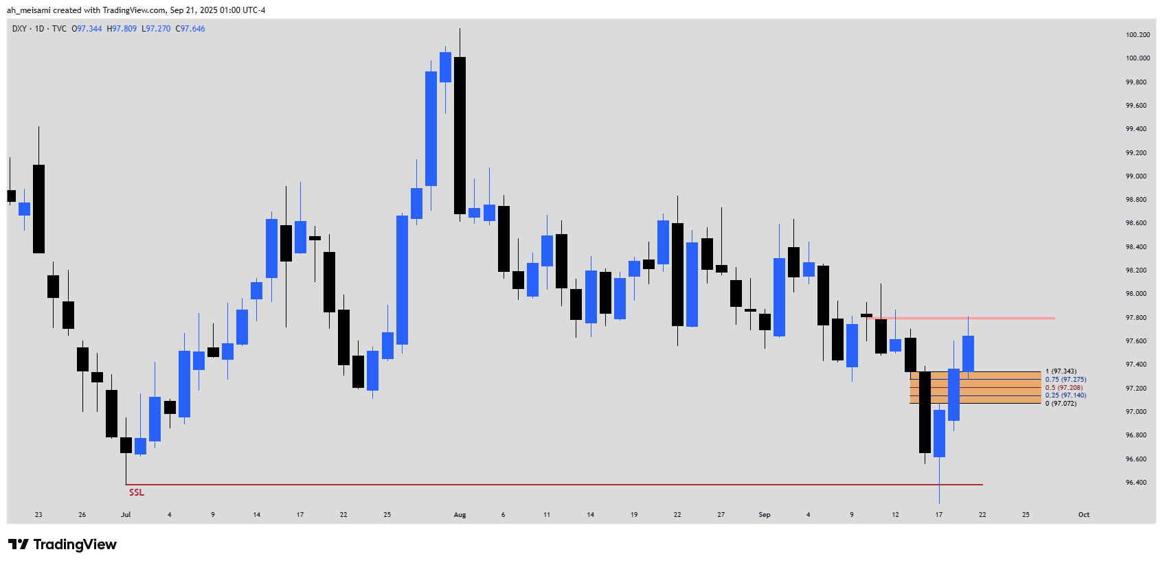

### DXY 5m Analysis

<https://www.tradingview.com/x/0Gboq7S4/>

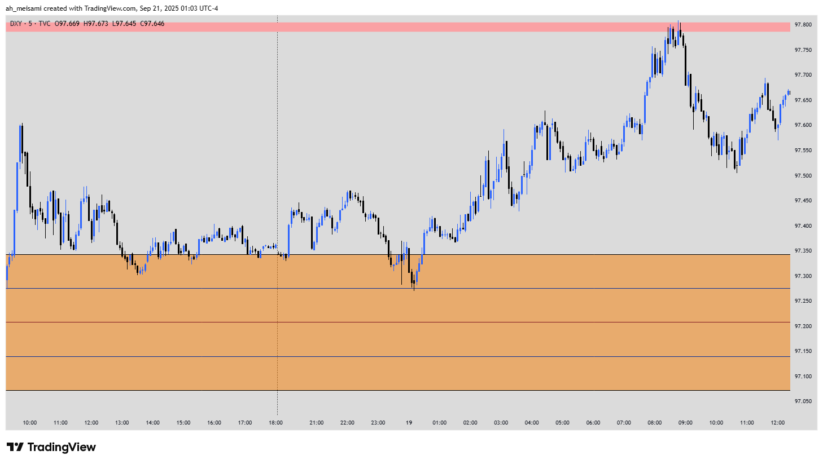

<https://www.tradingview.com/x/xqYoGIva/>

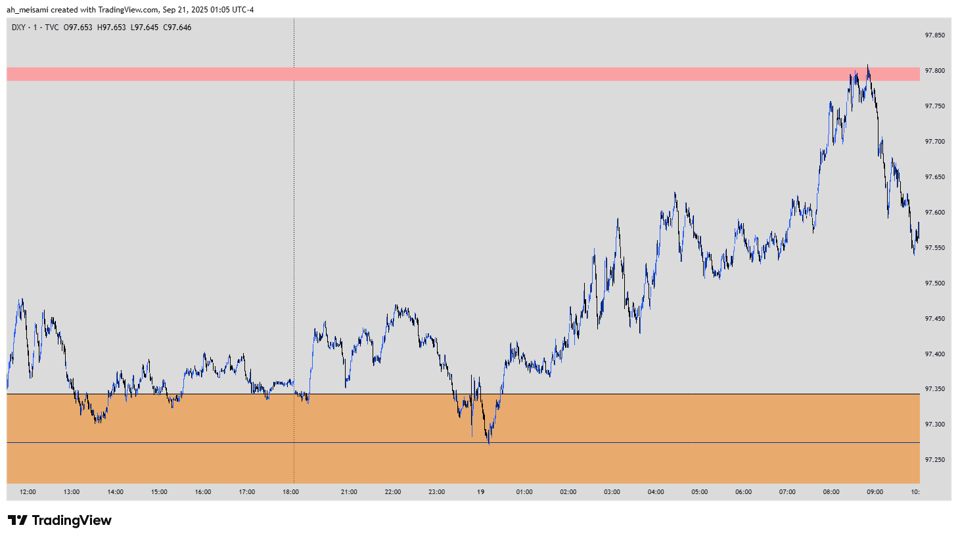

<https://www.tradingview.com/x/UaIydTfB/>

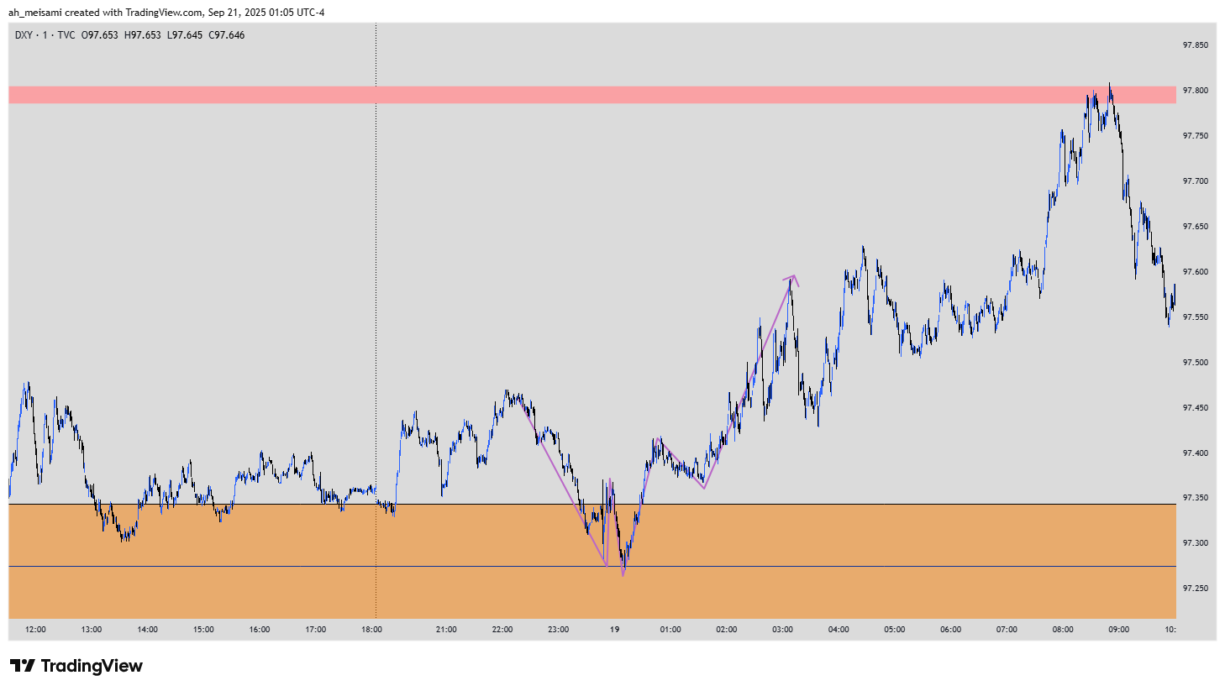

<https://www.tradingview.com/x/lwDs0KbZ/>

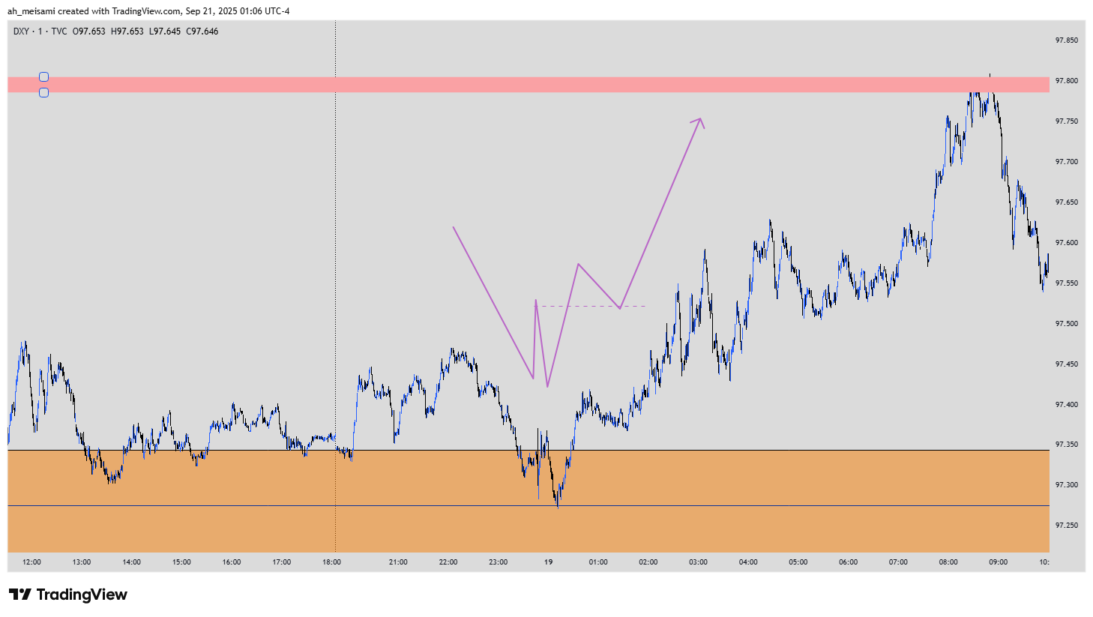

<https://www.tradingview.com/x/qa9BbzUm/>

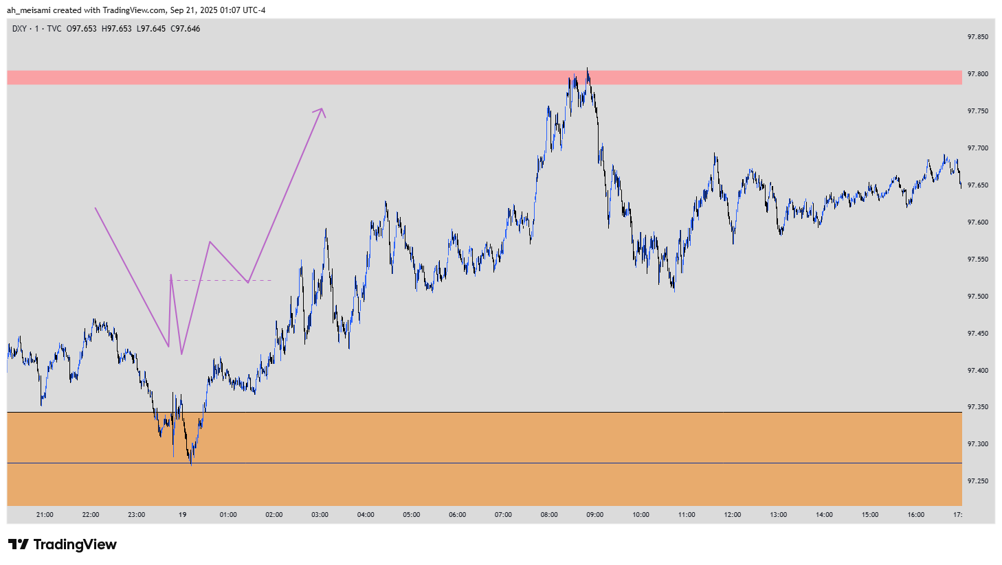

### DXY My Mistake ❤️

<https://www.tradingview.com/x/CMlVkK9v/>

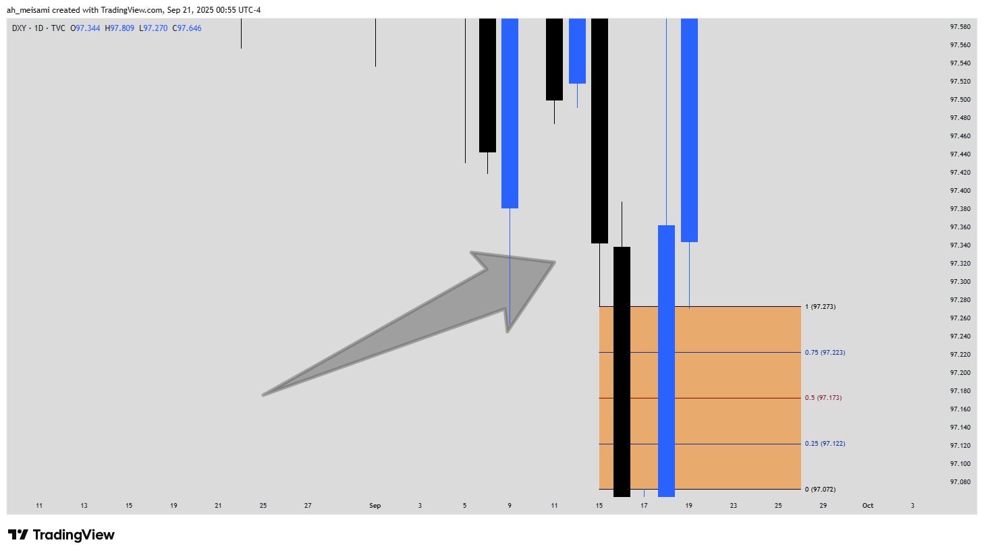

<https://www.tradingview.com/x/24uu8sNI/>

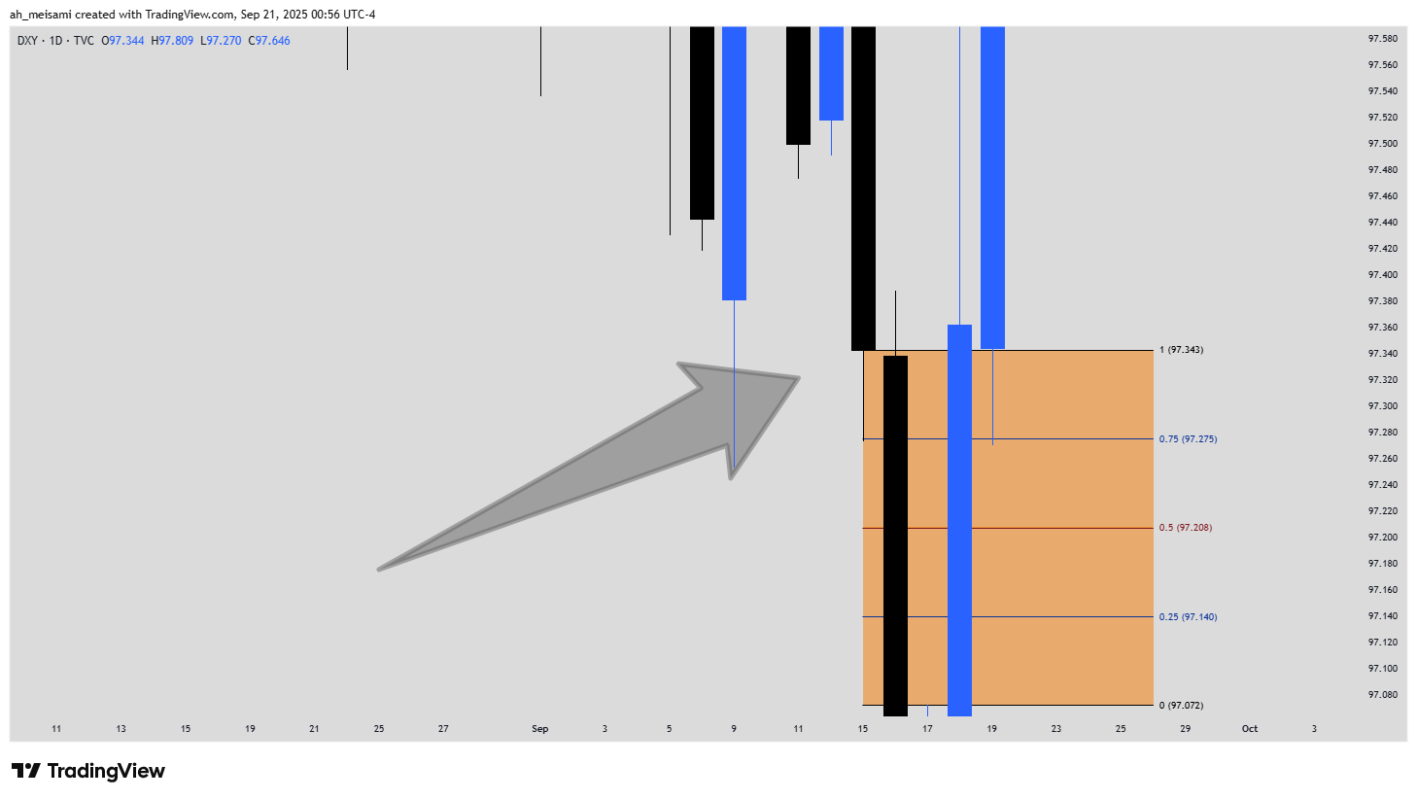

# GBPUSD Daily Analysis

<https://www.tradingview.com/x/Jn1PEl7h/>

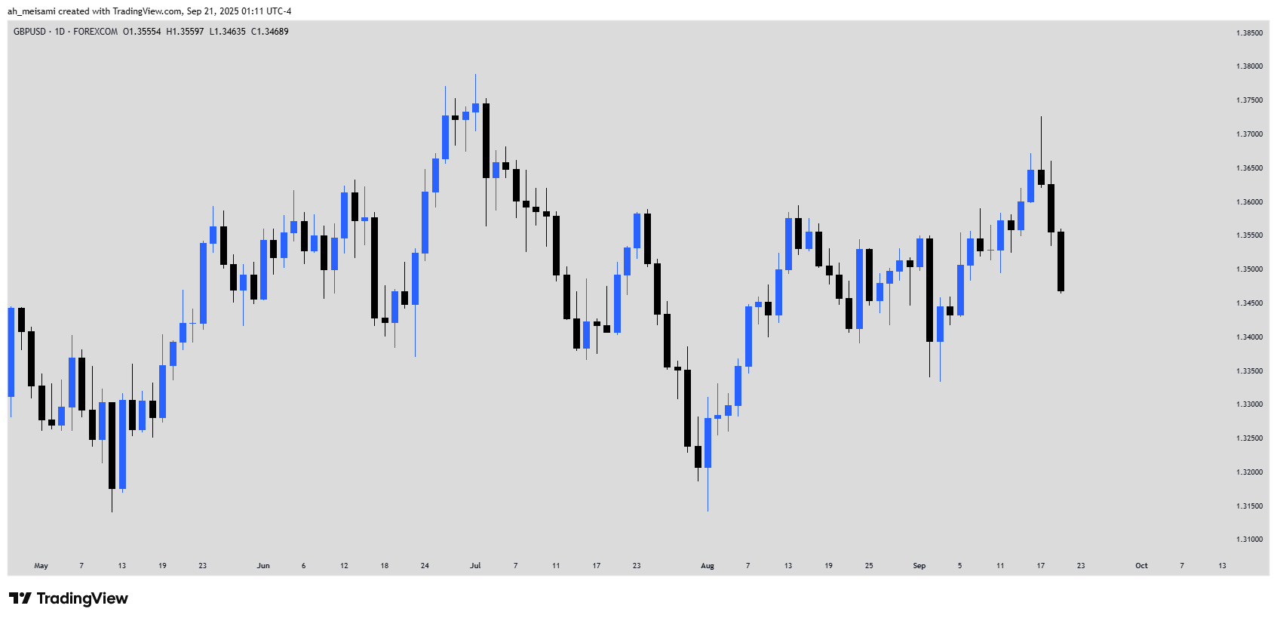

<https://www.tradingview.com/x/PV6Zw8Kq/>

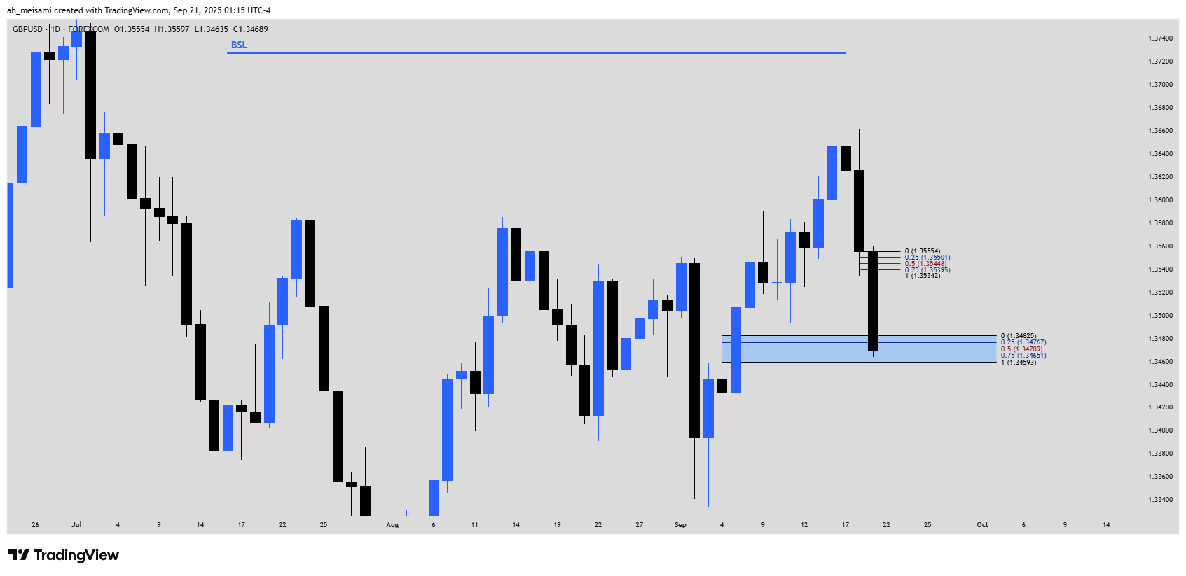

<https://www.tradingview.com/x/HoU0dKKn/>

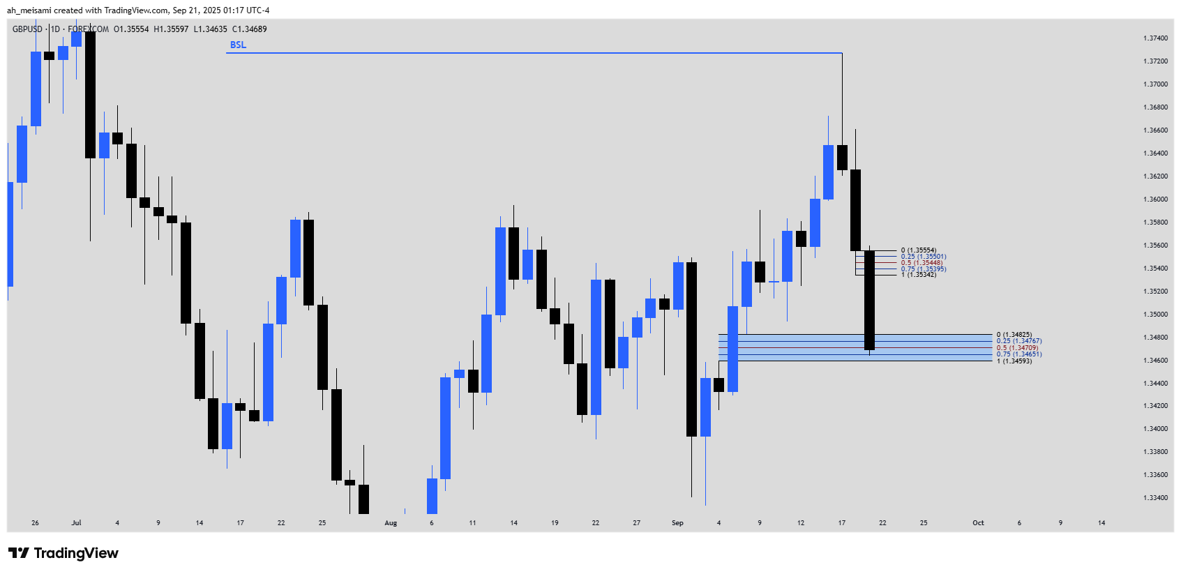

<https://www.tradingview.com/x/E7VZ17z4/>

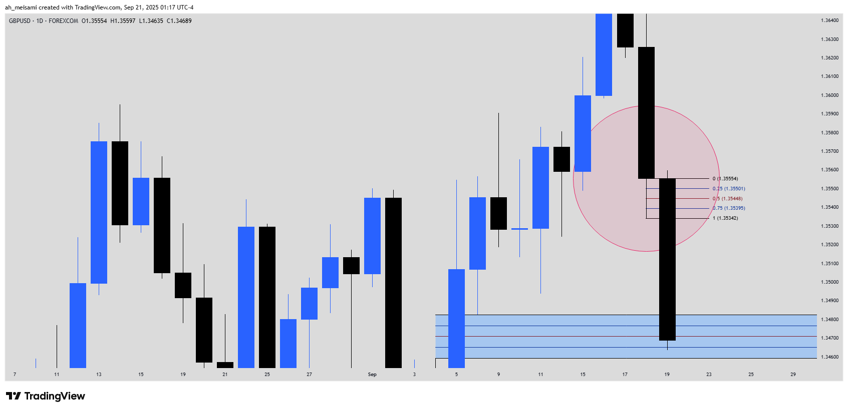

## GBPUSD 5m Analysis

<https://www.tradingview.com/x/r8Zx3DXP/>

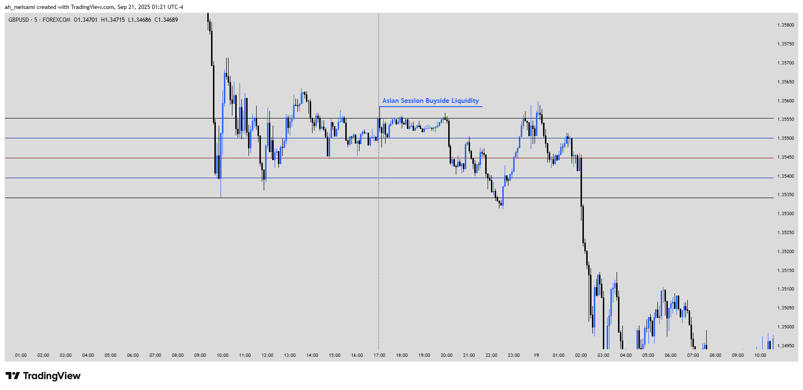

<https://www.tradingview.com/x/hksyY8NC/>

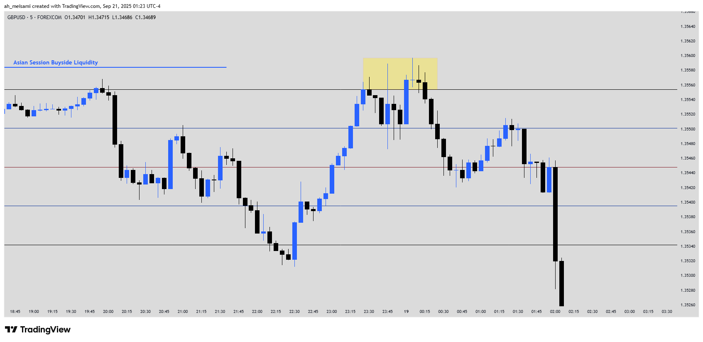

<https://www.tradingview.com/x/YcWFBGrB/>

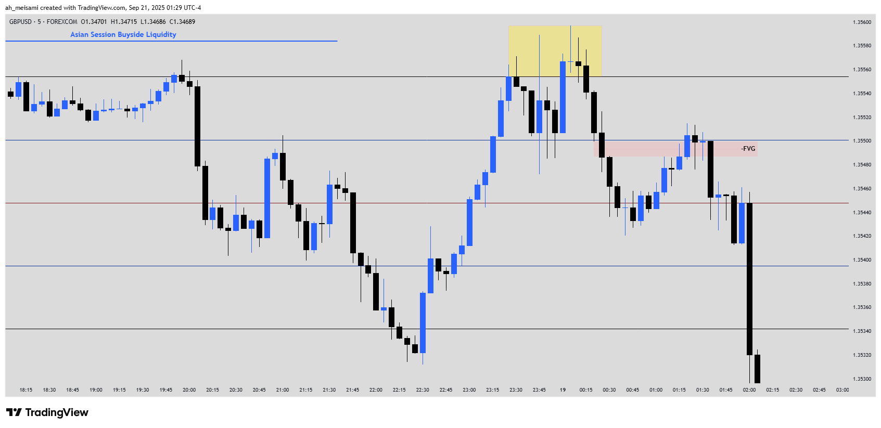

<https://www.tradingview.com/x/i03FgVaE/>

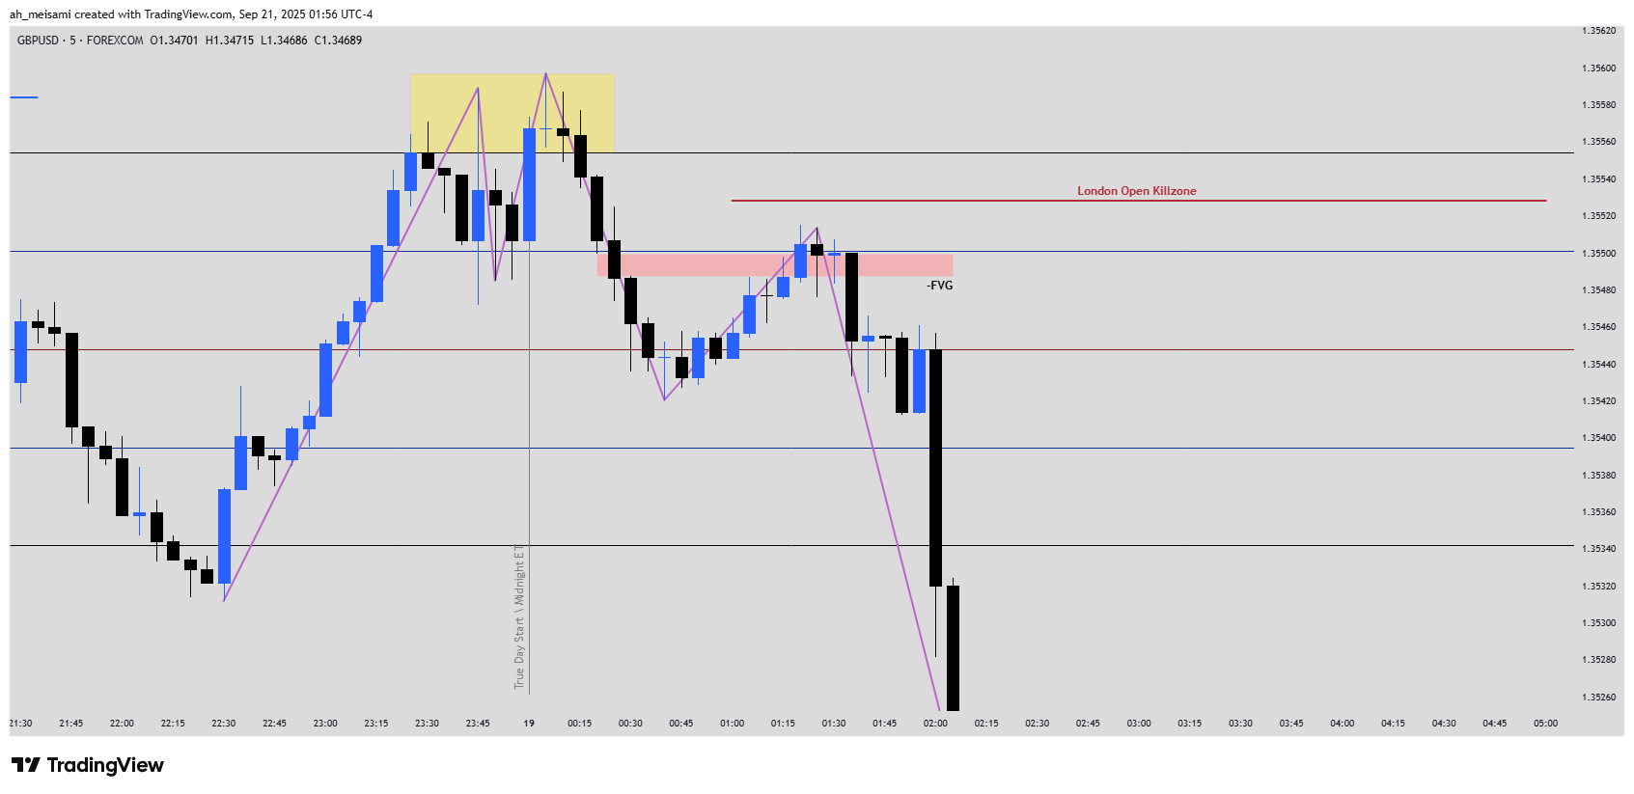

<https://www.tradingview.com/x/pbJqOSVD/>

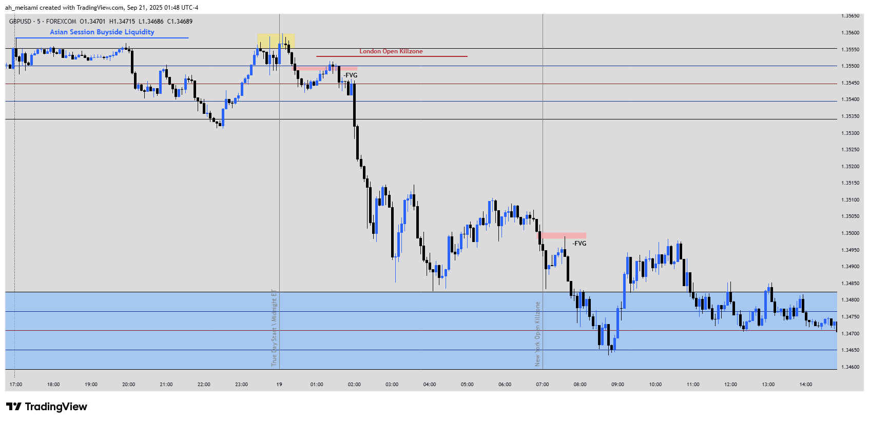

<https://www.tradingview.com/x/4ZD0WefW/>

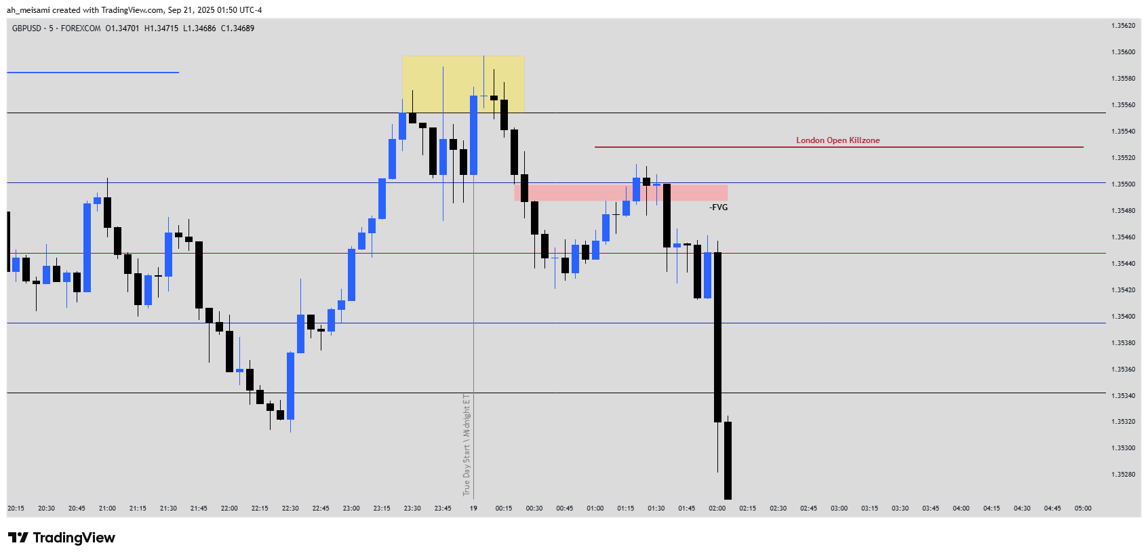

<https://www.tradingview.com/x/ryera3ne/>

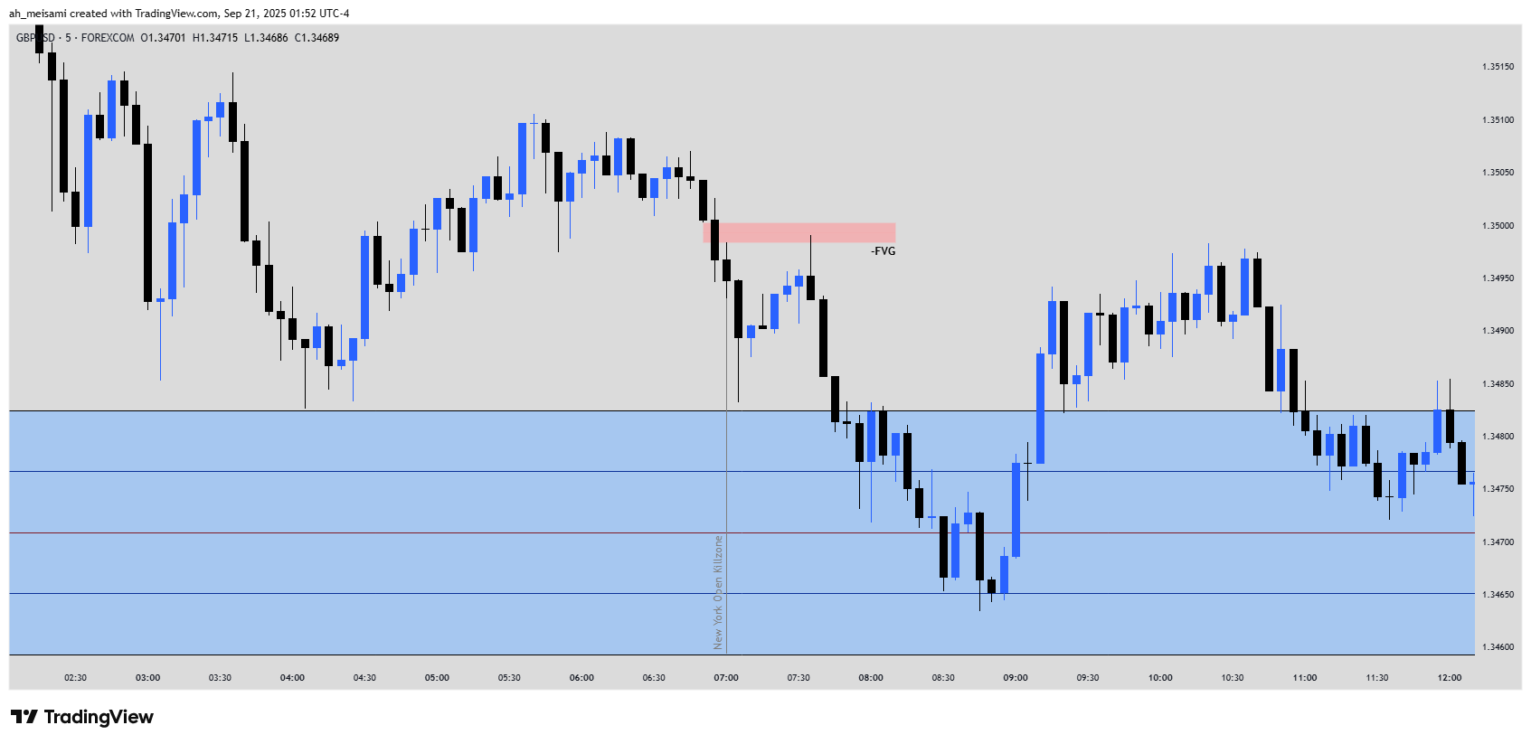

<https://www.tradingview.com/x/559Rk5Rq/>

